Top of Form

Lab 4 - SQL

Bottom of Form

Top of Form

Each problem is worth one point. No partial credit will be given. This lab is worth a total of 20 points.

**From this lab forward, please notice if a result table is in a particular order. If it is you must use the order by clause. Failure to do so will result in 0 points for that specific problem.**

**Place all answers into ONE .sql file. Attach that file to the dropbox in D2L. Only one .sql file will be accepted.**

**\*\*\*\* Use the AP table space for the following questions \*\*\*\***

**UPDATE:  for questions 1-4 correct the SQL statements so they do not generate an ERROR.**

**1.    Write an SQL statement to generate the following error message: ORA-00904. Use the  
        Invoices table.**

**SELECT invlice_id  
            FROM ap.invoices;**

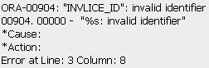

**2.    Write an SQL statement to generate the following error message: ORA-00942. Use the   
        Invoices table.**

**SELECT invoice_id  
            FROM ap.invoicdes;**

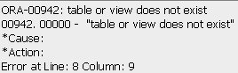

**3.    Write an SQL statement to generate the following error message: ORA-00933. Use the   
        Invoices table.**

**SELECT invoice_id  
            FROM ap.invoices  
            WHER invoice_id = 1;**

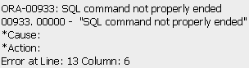

**4.    Write an SQL statement to generate the following error message: ORA-00936. Use the   
        Invoices table.**

**SELECT invoice_id,  
            FROM ap.invoices  
            WHERE invoice_id = 1;**

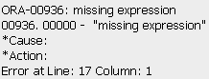

**5.    Display formatted invoice totals as dollar amounts as shown below. Use the Invoices table.  
       Partial Result Table (114 rows total)**

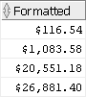

**6.    Display invoice totals in scientific notation as shown below. Use the Invoices table.   
       Partial Result Table (114 rows total)**

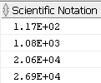

**7.    Display the following result table. Use the Invoices table.  
        Partial Result Table (114 rows total)**

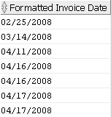

**8.    Display the invoices for May 7, 2014 as shown below. Use the Invoices table.**



**\*\*\*\* Use the Student table space for the following questions \*\*\*\***

**9.    Display the enrollment information for students enrolling on January 30, 2007 as shown below. Use the   
       Enrollment table.**

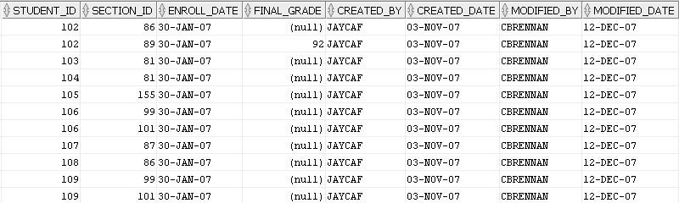

**10.  Display the city, state and zip as one column. You must use the concat function to receive   
       credit. Use the Zipcode table.**

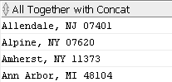

**Partial Result Table (227 rows total)**

**11.  Display the city, state and zip as one column shown below. You must use ||’s to receive   
        credit. Use the Zipcode table.**

**Partial Result Table (227 rows total)**

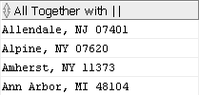

**12.  Display the city in upper case, lower case and mixed case as shown below. You must use one SQL      
        statement only. Use the Zipcode table.**

**Partial Result Table (227 rows total)**

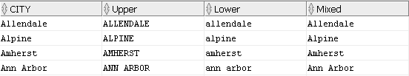

**13.  Display all cities whose number of characters are between 5 and 9 inclusive as shown below. Use the   
        Zipcode table.**

**Partial Result Table (156 rows total)**

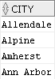

**14.  Display the 2nd, 3rd and 4th character of all cities as shown below. Use the Zipcode table.**

**Partial Result Table (227 rows total)**

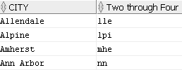

**15.  Display the last 3 characters of all cities as shown below. Use the Zipcode table.  
        Partial Result Table (227 rows total)**

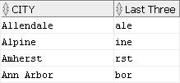

**16.  Display all rows in the Grade_Summary table as shown below. For any null values in the Midterm_Grade   
        column, display 0. Use the Grade_Summary table.**

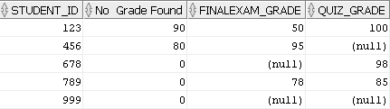

**17.  Display all students that are doctors as shown below. Replace the Dr. salutation with Doctor. Use the   
      Student table.**

**4.17**

**18.  Remove all spaces at the end of the street address as shown below. Use the Student table.**

**Partial Result Table (268 rows total)**

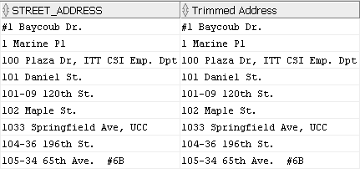

**\*\*\*\* Use the Dual table for the following questions \*\*\*\***

**19.  Convert a character string to a number. Use the Dual table.**

**4.19**

**20.  Using the SQRT function, create the following result table. Use the Dual table.**

**4.20**

Bottom of Form